***Directions:* *Provide Snippets of your code below and the interface based off the problem given to you.***

1. Create an application that stores data about your movie collection in a file. The application should have a structure to hold the following fields: Movie Name, Year Produced, Running Time, and Rating. The application should allow the user to save the data to a file, search the file for a movie by name, and print a report listing all the movies records in the file.

**Details:**

The file menu will have the “Save Record” and “Exit” option.

The search menu will be a separate message box that will allow the user to enter the name of the video.

The report menu will allow the user to print instantly to the printer.

The help menu will have the “About” option explaining what this program is about.

**User Interface:**

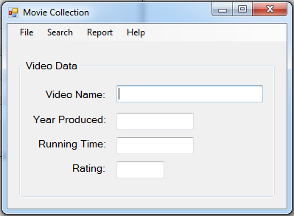

**Menu System:**

